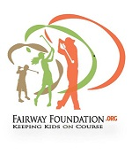
FAIRWAY FOUNDATION
2020 PARENT/PLAYER REGISTRATION AND COVID-19 ADDENDUM

FAIRWAY FOUNDATION MISSION
To provide youth in the Twin Cities structured programs focused on education & recreation balance, cultural enrichment and life skills by instilling the values inherent in the game of golf: honesty, self-reliance, sportsmanship, and integrity. We strive to Keep Kids on Course by providing experiences that enable our participants to make responsible decisions and produce strong, community leaders for the future. We will achieve this mission via collaborative partnerships with community based & fraternal organizations, churches, and private/public organizations. Through programs focused on education & recreation, life skills, cultural enrichment, and mentoring

Registration & Permission Slip

Please print

Name: __________________________________________________M__ F__ DOB: ________ Shirt Size_____
Name: __________________________________________________M__ F__ DOB: ________ Shirt Size_____
Name: __________________________________________________M__ F__ DOB: ________ Shirt Size_____

Address: ____________________________________________________________________________________

City: ________________________ State: _____Zip:_________ Child Ph# (Optional): ____________________

Parent/Guardian Name(s): _____________________________________________________________________

Address (if different from Childs):________________________________________________________________

City: __________________ State: _____Zip:________ Parent Ph #:H________________C_________________

E-mail(s): ____________________________________________________________________________________

Years of Golf Experience OR in Fairway Foundation Program: ________

Ethnicity (Optional): ___African American ____Caucasian ____Asian/Pacific Islander

____American Indian/Alaska Native ____Latino/Hispanic _____Other

Household Income* (yearly): ____Less than $20,000 ____$20,001-$40,000 ___$40,001-$60,000

____60,001-$85,000 ____more than $85,000 *Income information is for grant requirements

Please specify any medical (allergies, asthma, etc), dietary, or other special needs of your child(ern) for which FWF should be aware:

_____________________________________________________________________________________________
_____________________________________________________________________________________________

2020 Participation Fee: $75 per child
NOTE: Please Contact Erick Goodlow… regarding scholarship or payment arrangements at 763-226-1636 if needed.
Thank You.

Tigers Pledge

Tigers, promise/pledge, always to uphold the values inherent in the game of golf: honesty, self-reliance, sportsmanship, and integrity. Tigers will strive to grow the game of golf by being timely, respectful, coachable and appropriately attired.

Tiger Signature: ___________________________________________________________

Parental/Guardian Liability Waiver & Permission

I give permission for the above registrant to participate in the Fairway Foundation’s 2017 clinics and other programs, I assume all risks and hazards incidental to the conduct of this activity, including any transportation that I do not provide or arrange for. I agree that his/her ability to participate is conditioned on our agreements to assume all risks and hazards associated with such participation, and this agreement to release the Fairway Foundation, its directors, officers, employees and other representatives from any known or unknown claims, causes of actions, damages, or other liabilities of any kind relating to or arising out of such participation. (Please cross out the following paragraph before signing if you do not wish to grant rights to use of your child's name or recorded images). Additionally, I acknowledge that the Fairway Foundation may photograph or record Fairway Foundation clinics or other programs for fundraising, promotional or other purposes, or may authorize others to do so. I hereby consent to such use of my child's name, voice, photographs or other recorded images on an unrestricted basis and without compensation.

Signature: ______________________________________________________ Status: Parent______ Legal Guardian _______

************************************************************************************************************

Emergency Contact(s)_______________________________________________ Phone: ________________________________

Email(s)____________________________________________________________________________________________________

Relationship to child: __________________________________________________________________________________________

Medical Insurance Provider

Name:________________________________________________

Phone:_______________________________________________

Address:_____________________________________________

Insurance group #____________________________________

Office Use Only
Program Fee:
___Credit Card (last 4 digits)_______ _____Cash ____Check (enter#_________)

Current Level: ____ Tiger ___Jr. ____Cub

Assumption of the Risk and Waiver of Liability Relating to Coronavirus/COVID-19
The novel coronavirus, COVID-19, has been declared a worldwide pandemic by the World Health Organization. COVID-19 is extremely contagious and is believed to spread mainly from person-to-person contact. As a result, federal, state, and local governments and federal and state health agencies recommend social distancing and have, in many locations, prohibited the congregation of groups of people.
Fairway Foundation (FWF) has put in place preventative measures to reduce the spread of COVID-19; however, FWF cannot guarantee that you or your child(ren) will not become infected with COVID-19. Further, participating in Fairway Foundation & associated tournaments could increase your risk and your child(ren)’s risk of contracting COVID-19.
By signing this agreement, I acknowledge the contagious nature of COVID-19 and voluntarily assume the risk that my child(ren) and I may be exposed to or infected by COVID-19 by participating in Fairway Foundation (FWF) Golf and that such exposure or infection may result in personal injury, illness, permanent disability, and death. I understand that the risk of becoming exposed to or infected by COVID-19 at FWF activities may result from the actions, omissions, or negligence of myself and others, including, but not limited to, FWF leadership, coaches, volunteers, and program participants and their families.
I voluntarily agree to assume all of the foregoing risks and accept sole responsibility for any injury to my child(ren) or myself (including, but not limited to, personal injury, disability, and death), illness, damage, loss, claim, liability, or expense, of any kind, that I or my child(ren) may experience or incur in connection with my child(ren)’s participating in FWF Golf Events or participation in FWF Golf activities (“Claims”). On my behalf, and on behalf of my children, I hereby release, covenant not to sue, discharge, and hold harmless Fairway Foundation, its board of directors, coaches, volunteers, and representatives, of and from the Claims, including all liabilities, claims, actions, damages, costs or expenses of any kind arising out of or relating thereto. I understand and agree that this release includes any Claims based on the actions, omissions, or negligence of Fairway Foundation, its board of directors, coaches, and representatives, whether a COVID-19 infection occurs before, during, or after participation in any Fairway Foundation activities.

__________________________________________________________________________________
Signature of Parent/Guardian Date

__________________________________________________________________________________
Print Name of Parent/Guardian Name of Tiger(s)

Fairway Foundation Daily Screening (if necessary)
COVID-19 Screening
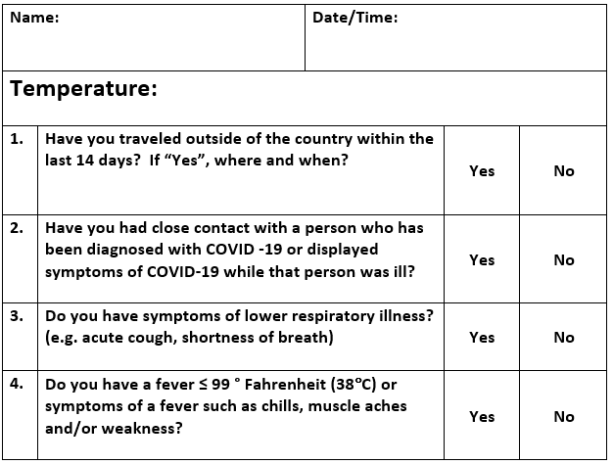
Note: Close contact is defined as:
Being within approximately 6 feet or within the room or care area for a prolonged period of time while not wearing recommended personal protective equipment (e.g. gowns, gloves, respirator, eye protection).
Having direct contact with infectious secretions (e.g. being coughed on) while not wearing recommended personal protective equipment.

Tiger Signature

